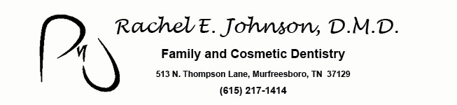

Post-Operative Instructions Following Tooth Extraction:

Our goal is for your healing process after an extraction to be as comfortable as possible. The removal of teeth is a surgical procedure, and post-operative care is imperative. Please follow all instructions to avoid any unnecessary pain and possible infection.
- Immediately following surgery, keep the gauze pad placed over the surgical area with pressure applied by biting down until the bleeding stops. If bleeding has not decreased in 3-4 hours, bite on a damped tea bag placed directly on the surgical site. The tannic acid in the tea helps the blood to clot.
- The clot that forms in the tooth socket MUST
remain in order for you to heal quickly and with a minimum of discomfort. This clot serves as a biologic barrier that protects the exposed bone in the socket from food and bacterial contamination.
- Try not to blow your nose, as this can increase bleeding while healing.
- DO NOT drink through a straw!
- It is advisable to restrict your diet to liquids and soft, non-spicy foods which are comfortable for you to eat. AVOID foods such as nuts, popcorn, sunflower seeds, potato chips, etc, that may become lodged in the socket areas.
- DO NOT smoke for at least 48 hours- smoking is very detrimental to healing.
- Always wash y our hands with soap and hot water before putting your fingers in your mouth to remove or place gauze pads.
- If you need to spit out blood or saliva, simply open your mouth and let the liquid flow out by gravity. DO NOT suck it from your gums with your tongue, and DO NOT expel it by force.
- Restrict your activities the day before surgery, and resume normal activity when you feel comfortable.
- Vigorous mouth rinsing or touching the affected area following surgery should be avoided for the first 24 hours. This may initiate bleeding caused by dislodging the blood clot that has formed. After the first day, used warm salt water rinse every 4 hours and after meals to flush out particles of food and debris that may lodge in the area.
- You can brush your teeth the night of surgery, but brush and rinse gently.

Following these instructions will assist you, but if you have any questions about your progress- Please call Dr. Rachel E. Johnson’s Office at (615) 217-1414.

